San Jose State University

EE250 (Section 2) Fall 2019 Prof. Kamali

Problem Set #10
- Problem 9.65
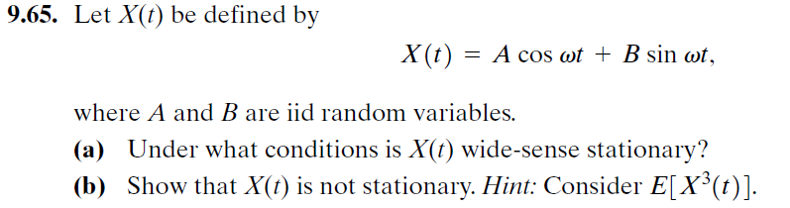

- [Final Exam, Spring 2007] Suppose 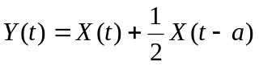 where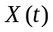is a wide sense stationary process with zero mean and auto-covariance function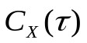.

- Find 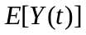and 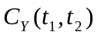.
- Is 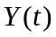wide sense stationary?

- [Final Exam, Spring 2008] Suppose 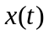is a zero mean stationary random process with auto-correlation function
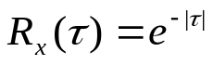

and 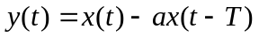where 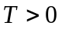.

- Find the auto-correlation function of 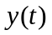.
- Find to minimize 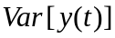.

- [Final Exam, Fall 2014] Consider the random process 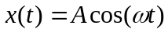, whereis a zero mean and unit variance Gaussian random variable.

- Find the mean and auto-covariance of 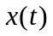.
- Is stationary?

- [Final Exam, Spring 2015] Consider the random process 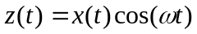 whereis a zero mean stationary process with the auto-correlation 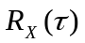.

- Find 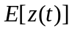 and 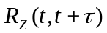.
- Is 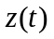stationary?

- [Final, Fall 2014] Suppose is a random process which starts at time 0 at 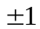with equal probability (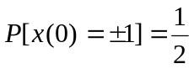) and goes up by one every time a Poisson event takes place. The Poisson events happen with the rate of 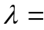1 event/second. Find 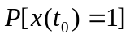for 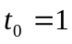.

- [Final Exam, Fall 2014] Consider the process 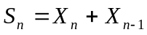 where 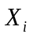's are iid and 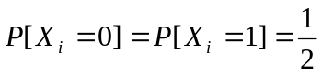.

a) Find the pmf of .
b) Find the joint pmf of and 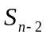.
c) Find the joint pmf of and 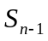.

- [Final, Fall 2014] Consider the random process , whereis a zero mean and unit variance Gaussian random variable.

- Find the mean and auto-covariance of .
- Is stationary?

